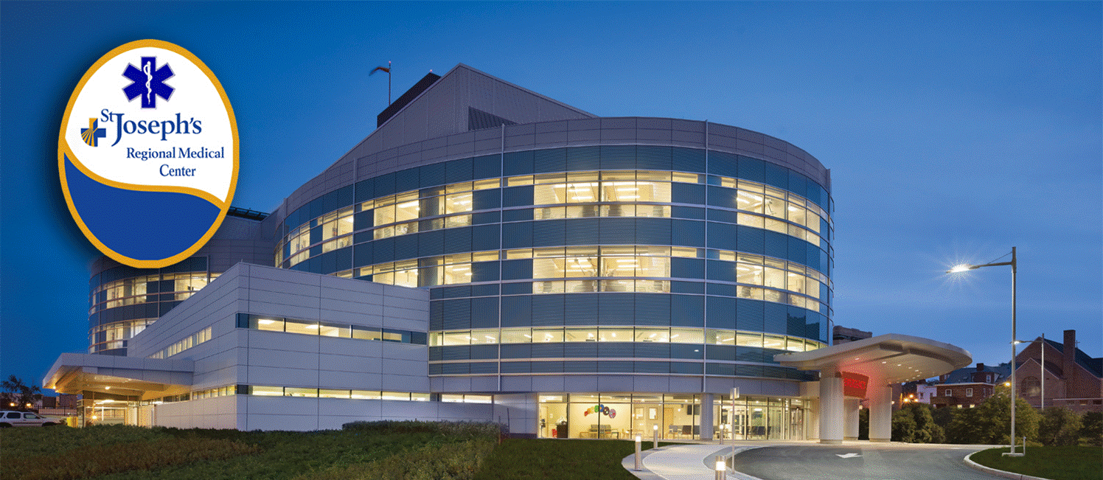
Name: Today’s Date:
**PLEASE NOTE: As of October 2015, SJRMC will be participating exclusively in the ACGME Match
4TH YEAR EMERGENCY MEDICINE ROTATION APPLICATION
4TH YEAR EM ROTATION
Address:

Phone #: Email:

Rotation Date Choice #1: Choice #2:

Hometown (original):

Medical School:
Year: MS-IV only
Anticipated Graduation Date (Month/Year):

Undergraduate School:
Degree:

Medical Field of Interest:

COMLEX Step 1 Score (if taken):
USMLE Step 1 Score (if taken):
Would this rotation be core or elective?
How many previous EM rotations have you done?
List 3 extra-curricular activities:

List any research experience or publications below:
1)
2)
(continued onto next page)

INSERT PHOTO HERE

For any questions, please email sjrmcer@gmail.com Please send completed application to this email address.

